SIMATS ENGINEERING (SAVEETHA SCHOOL OF ENGINEERING)
Department of Computer Science and Engineering
CO2_AT3 — CASE STUDY

Course Code: | DSA06 | Course Title: | Data Handling and Visualization
CO Assessed: | CO2 – Evaluation (BL5) | Assessment: | Assessment Tool 3 – Case Study
Weightage: | 20% of CIA | Total Marks: | 20 (2 Questions × 10 Marks)
CO2 Statement: | Analyze real-world data scenarios and evaluate/justify the most appropriate chart types, coordinate systems, color scales, and dashboard designs to represent them.(BL5)
Student Name: | P. SIDDARDHA | Reg. No.: | 192424271
Section / Batch: | AIDS/2024 | Date: | 04-08-2026

Code of Conduct
I _P. SIDDARDHA (192424271) _ (Name / Reg No) certify that this submission is my original work and that I have adhered to the guidelines specified for this assessment. I understand that any violation of academic integrity rules will result in disciplinary action.

Signature of the Student: ___P. SIDDARDHA__

Instructions
- This test contains 2 case-study questions, each carrying 10 marks. Total: 20 Marks.
- No negative marking. Unanswered questions carry zero marks.
- No calculators or electronic devices permitted.
- Duration: 90 minutes.
- Each case study has four sub-parts (a–d); answer all parts for full marks.
- Support your answers with brief calculations or justifications where relevant.
- Diagrams may be hand-drawn or clearly described in words if drawing tools are unavailable.

Annexure A – CASE STUDY

CO2 AT3 – CASE STUDY

Question 3 (10 Marks)
Scenario
An investment company wants to analyse portfolio performance by comparing portfolio holdings, monthly returns, and asset allocation. The dashboard should clearly identify the riskiest month and effectively communicate portfolio performance.

Aim
To evaluate portfolio performance by selecting appropriate visualizations for holdings, monthly returns, and asset allocation, and to develop a coordinated dashboard that effectively communicates investment trends and risk.

Dataset
Month | Holdings | Monthly Return (%) | Asset Class | Allocation (%)
January | 120000 | 4.5 | Equity | 35
February | 180000 | -2.8 | Debt | 20
March | 250000 | 6.2 | Gold | 15
April | 450000 | -5.5 | Real Estate | 12
May | 750000 | 8.0 | Cash | 10
June | 1200000 | -7.2 | Mutual Funds | 8

Dashboard Design
The dashboard combines two coordinated visualizations:
Chart 1 – Portfolio Holdings Line Chart
- X-axis: Month
- Y-axis: Holdings
- Scale: Logarithmic
- Purpose: Display portfolio growth across six months.
Chart 2 – Monthly Returns Bar Chart
- X-axis: Month
- Y-axis: Monthly Return (%)
- Colour:
  - Green → Positive Returns
  - Red → Negative Returns
- Purpose: Clearly distinguish profit and loss months.
The dashboard combines these two charts to provide a comprehensive view of investment growth and monthly performance.

Answer (a)
The Portfolio Holdings Line Chart requires a logarithmic Y-axis because the holdings increase from 120,000 to 1,200,000, representing a tenfold increase.
A linear scale is unsuitable because the smaller values would be compressed near the bottom of the chart, making differences between the early months difficult to observe. A logarithmic scale distributes the values proportionally, allowing both smaller and larger holdings to be displayed clearly while preserving the overall growth trend.

Answer (b)
A Bar Chart is the most appropriate visualization for monthly returns because it clearly separates positive and negative values.
The colour mapping should be:
- Green → Positive Returns
- Red → Negative Returns
This diverging colour scheme immediately distinguishes profitable months from loss-making months. Positive returns appear above the zero line, while negative returns extend below the zero line, making monthly performance easy to interpret.

Answer (c)
A Pie Chart is the most suitable visualization for the six-category asset allocation because the allocation values represent parts of a whole portfolio.
The pie chart clearly shows the percentage contribution of each asset class:
- Equity – 35%
- Debt – 20%
- Gold – 15%
- Real Estate – 12%
- Cash – 10%
- Mutual Funds – 8%
A Bar Chart could also display these percentages; however, it does not emphasize that the values together represent 100% of the portfolio. Therefore, a Pie Chart provides a more intuitive representation of proportional asset allocation.

Answer (d)
The dashboard combines the following two coordinated charts:
- Portfolio Holdings Line Chart
- Monthly Returns Bar Chart
These charts share the common monthly timeline, enabling users to compare portfolio growth with monthly investment performance.
Annotation
June recorded the highest loss (-7.2%), making it the riskiest month in the investment period.
Narrative Insight
The dashboard shows that although portfolio holdings increased steadily throughout the six months, investment returns fluctuated considerably. The largest decline occurred in June, indicating that despite overall portfolio growth, investors experienced the highest monthly loss during this period.

Result
The coordinated dashboard successfully combines portfolio holdings and monthly returns into a single visualization. The logarithmic scale accurately represents holdings growth, while the colour-coded bar chart clearly distinguishes profitable and loss-making months. The annotation immediately highlights the highest-risk period.
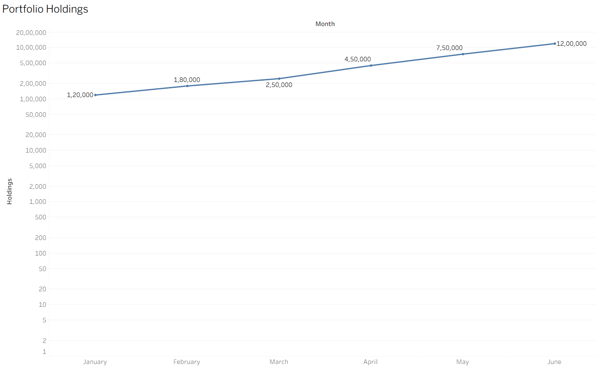

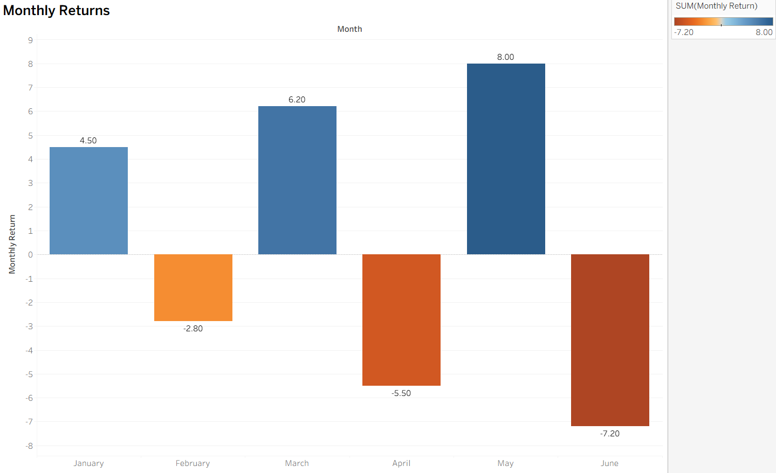
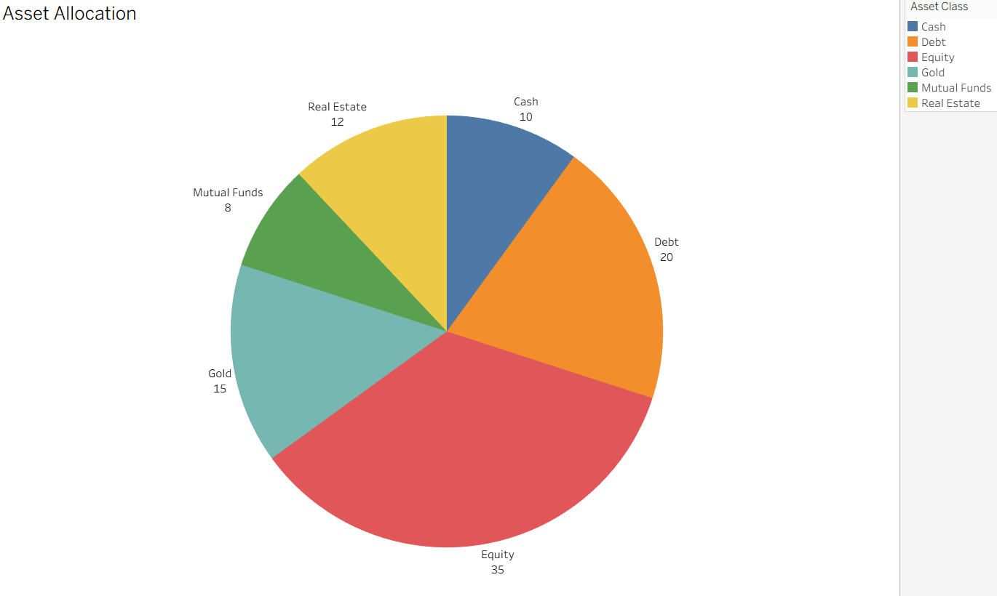
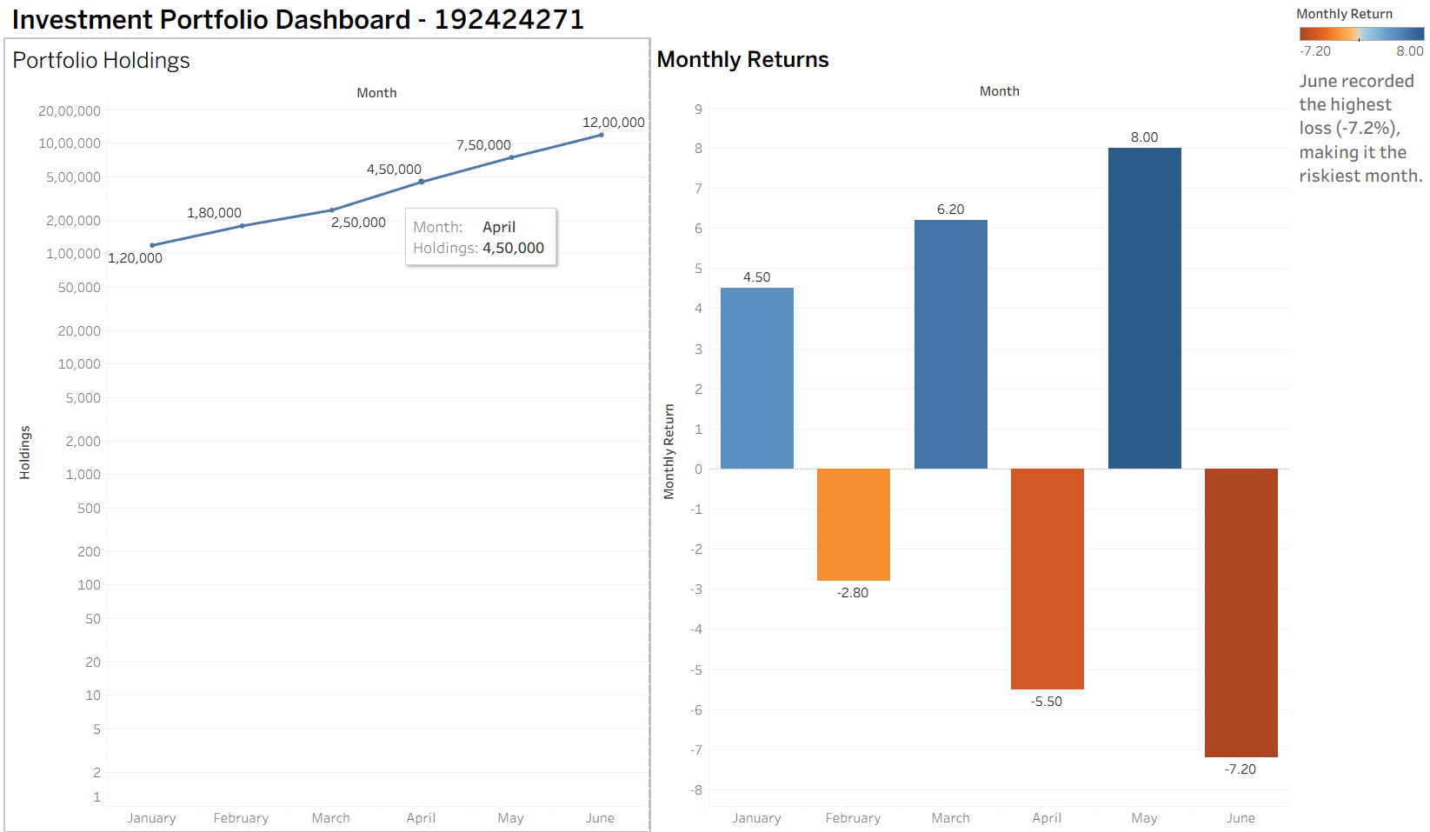

Conclusion
The proposed dashboard effectively evaluates portfolio performance by combining appropriate chart types, colour scales, and dashboard coordination. The logarithmic axis improves the readability of rapidly increasing holdings, the diverging colour scheme clearly communicates gains and losses, and the dashboard annotation identifies the riskiest month. The selected visualizations provide meaningful insights into portfolio growth and investment risk, satisfying the case study requirements.

Question 8 (10 Marks)
Scenario
A company wants to analyze employee information by comparing department headcount, attrition rate, salary distribution, and workweek time allocation. The dashboard should identify departments requiring retention efforts and evaluate appropriate visualization techniques.

Aim
To evaluate employee-related data by selecting suitable chart types, coordinate systems, and dashboard design techniques that effectively communicate workforce trends, salary distribution, and time allocation.

Dataset
Department | Headcount | Attrition Rate (%) | Salary | Activity | Hours
HR | 45 | 8 | 42000 | Work | 8
HR | 45 | 8 | 45000 | Work | 8
HR | 45 | 8 | 47000 | Work | 8
HR | 45 | 8 | 44000 | Work | 8
IT | 120 | 18 | 65000 | Sleep | 8
IT | 120 | 18 | 70000 | Sleep | 8
IT | 120 | 18 | 72000 | Sleep | 8
IT | 120 | 18 | 68000 | Sleep | 8
Sales | 90 | 22 | 52000 | Leisure | 4
Sales | 90 | 22 | 55000 | Leisure | 4
Sales | 90 | 22 | 57000 | Leisure | 4
Sales | 90 | 22 | 54000 | Leisure | 4
Finance | 60 | 10 | 62000 | Exercise | 2
Finance | 60 | 10 | 65000 | Exercise | 2
Finance | 60 | 10 | 67000 | Exercise | 2
Finance | 60 | 10 | 64000 | Exercise | 2
Marketing | 75 | 15 | 47000 | Meals | 2
Marketing | 75 | 15 | 50000 | Meals | 2
Marketing | 75 | 15 | 52000 | Meals | 2
Marketing | 75 | 15 | 49000 | Meals | 2
Operations | 110 | 20 | 58000 | Personal | 16
Operations | 110 | 20 | 60000 | Personal | 16
Operations | 110 | 20 | 62000 | Personal | 16
Operations | 110 | 20 | 59000 | Personal | 16

Dashboard Design
The dashboard combines two coordinated visualizations:
Chart 1 – Department Headcount (Bar Chart)
- X-axis: Department
- Y-axis: Headcount
- Purpose: Compare the number of employees across departments.
Chart 2 – Attrition Rate (Line Chart)
- X-axis: Department
- Y-axis: Attrition Rate (%)
- Purpose: Compare employee attrition across departments.
The two charts share the same department categories, enabling users to compare workforce size and employee turnover simultaneously.

Answer (a)
The most suitable dashboard combines a Bar Chart for department headcount and a Line Chart for attrition rate.
The Bar Chart clearly compares the number of employees in each department, while the Line Chart highlights differences in employee attrition rates. Combining these charts enables managers to identify departments with both high employee numbers and high attrition.
Annotation
Sales has the highest attrition rate (22%) and requires immediate retention action.
Narrative Insight
The dashboard shows that although IT has the largest workforce, Sales experiences the highest employee attrition. This indicates that improving employee retention should be a priority in the Sales department.

Answer (b)
A Box-and-Whisker Plot is the most appropriate chart for displaying the company-wide salary distribution.
This chart clearly represents:
- Minimum salary
- First Quartile (Q1)
- Median salary
- Third Quartile (Q3)
- Maximum salary
- Potential outliers
Compared with a bar chart or histogram, the Box-and-Whisker Plot provides a more effective summary of salary spread, central tendency, and possible outliers, making it the preferred visualization for salary analysis.

Answer (c)
The most suitable coordinate system is Polar Coordinates, represented using a Pie Chart, because the workweek time allocation represents parts of a fixed total.
The total workweek equals 40 hours.
Angle Calculation for an 8-Hour Component
Formula:
Angle = (Hours ÷ Total Hours) × 360°
For an 8-hour activity:
Angle = (8 ÷ 40) × 360° = 72°
Therefore, the Work activity occupies 72° of the pie chart.
A Pie Chart effectively communicates how the total workweek is divided among different activities and clearly illustrates proportional relationships.

Answer (d)
Although 3D Pie Charts may appear visually attractive, they introduce several visualization problems.
- Perspective distortion makes slices at the front appear larger than they actually are.
- Smaller slices may become partially hidden behind larger slices.
- Comparing angles and proportions becomes more difficult.
- Labels can overlap or become harder to read.
- Overall readability and interpretation decrease.
A standard 2D Pie Chart provides a more accurate and reliable representation of proportional data and is therefore recommended for dashboard development.

Result
The Human Resource Dashboard successfully combines department headcount and attrition rate into a coordinated visualization. The dashboard clearly identifies the department requiring immediate retention efforts, while the Box-and-Whisker Plot effectively summarizes salary distribution and the Pie Chart accurately represents workweek time allocation.
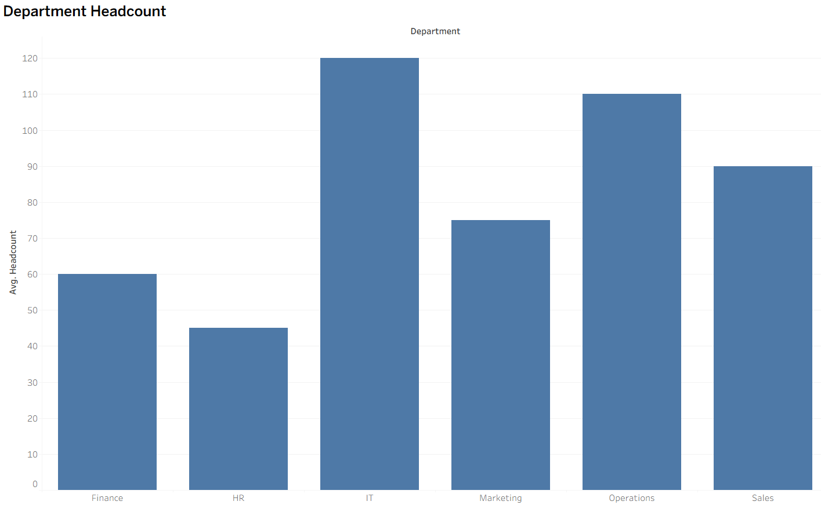
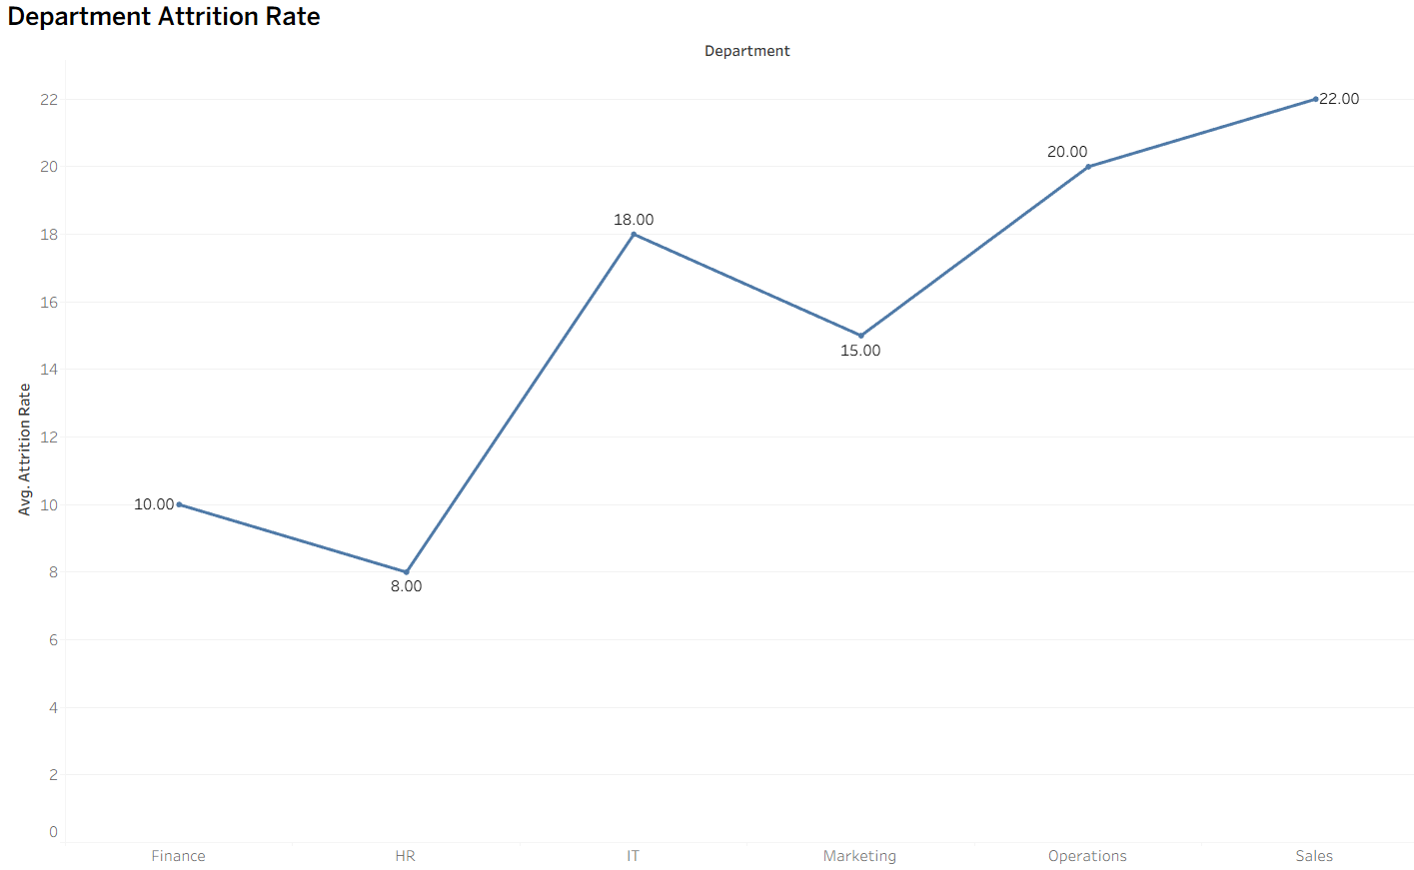
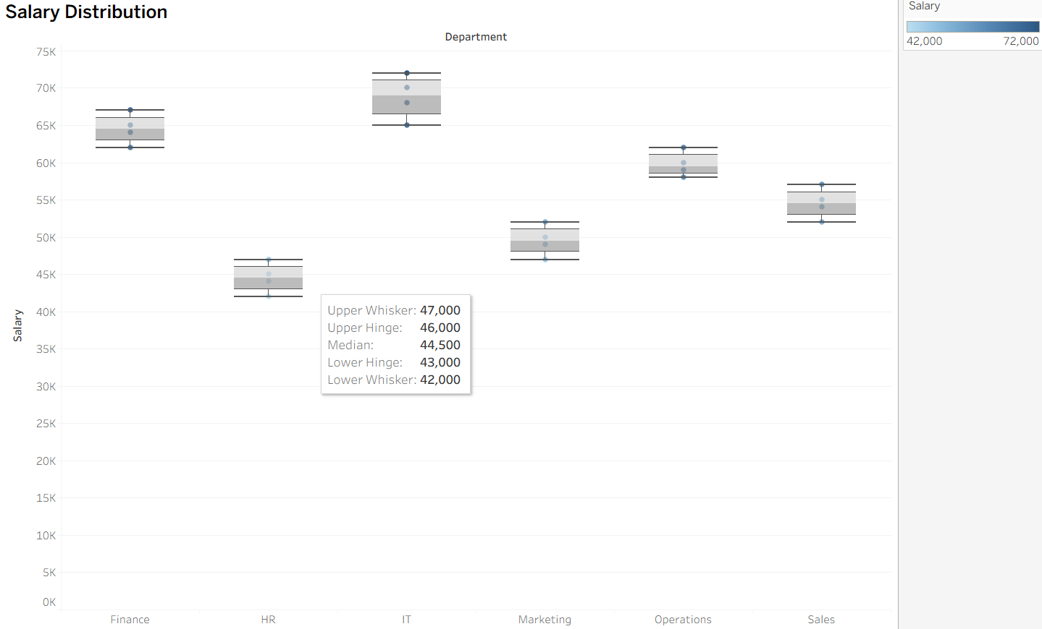

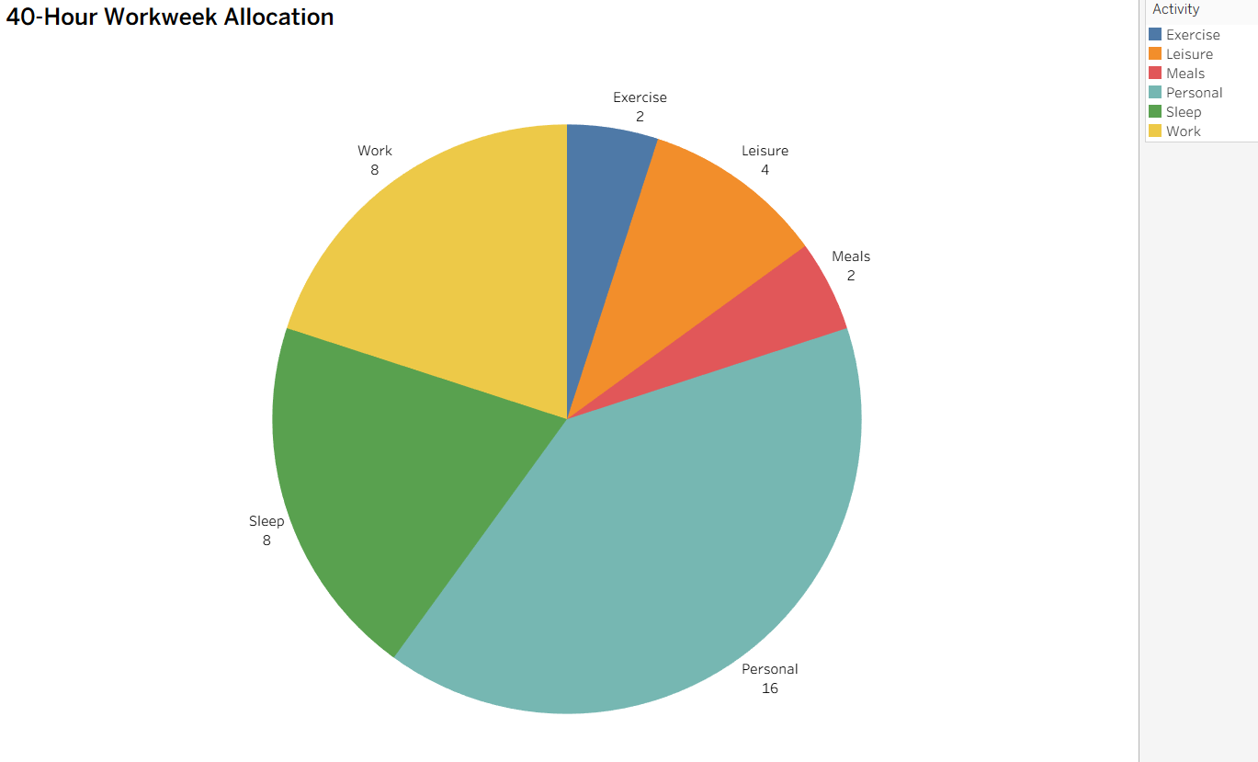
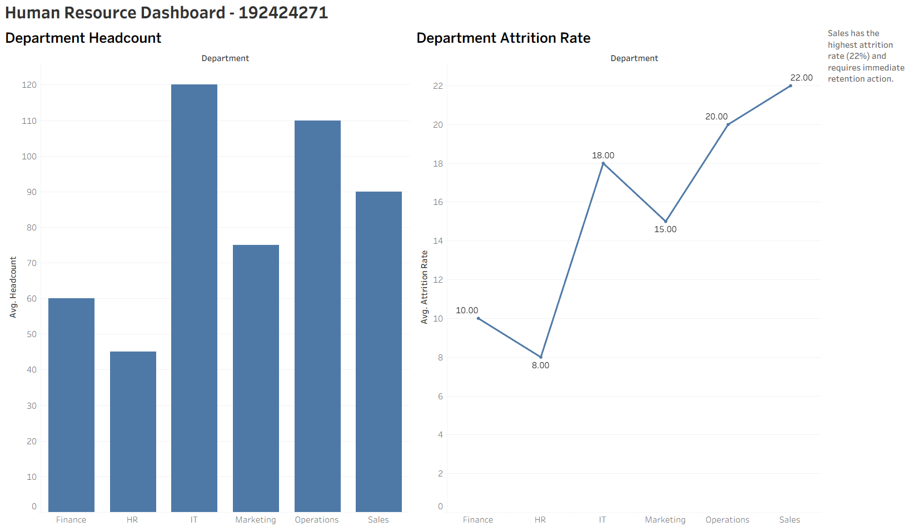
Conclusion
The proposed dashboard effectively evaluates workforce performance by integrating appropriate chart types, coordinate systems, and dashboard design principles. The coordinated visualizations, accurate annotation, salary distribution analysis, and polar coordinate representation provide meaningful insights into employee management and organizational performance. The critique of 3D Pie Charts further demonstrates sound visualization principles.
Rubrics for Calculation ASSESSMENT RUBRIC
AT3 — Case Study
CO2 · BT5: Evaluate ·
This rubric is used to assess student responses to the CO2-AT3 Case Study questions, in which students analyze a realistic multi-part scenario and select, justify, design, and critique appropriate visualizations across chart types, coordinate systems, color scales, and dashboard development.

Criteria | Weightage | Level 4 – Exemplary | Level 3 – Proficient | Level 2 – Developing | Level 1 – Beginning
Understanding of Concepts | 25% | Demonstrates thorough understanding of the full range of chart types, coordinate systems, and color scales relevant to the case, and correctly identifies which apply to each sub-part. | Good understanding of the relevant concepts, with only minor gaps in identifying appropriate chart types, scales, or color choices. | Basic understanding, but with some misconceptions about which visualization techniques suit the scenario's data. | Poor understanding of core concepts; proposes techniques fundamentally unsuited to the case study's data.
Explanation | 25% | Provides detailed, well-reasoned justification for every design decision and critique, explicitly tied to specific details of the case. | Provides clear justification for most decisions and critiques, with adequate reasoning. | Justification is limited or generic; decisions are stated without sufficient reasoning tied to the case. | Little or no justification provided; answers are unsupported assertions.
Application | 20% | Effectively applies visualization concepts to analyze and solve every sub-part of the case, including any calculations, with well-reasoned conclusions. | Applies concepts correctly to most sub-parts, with only minor errors. | Limited application; some sub-parts are weakly addressed or only partially correct. | Fails to apply appropriate concepts; sub-parts are left unaddressed or answered incorrectly.
Organization | 15% | The response is clearly structured, addressing every sub-part (a–d) in a logical sequence with coherent overall flow. | The response is organized and addresses each sub-part, with only minor issues in flow or clarity. | Basic structure; sub-parts are addressed but the response lacks clarity or a logical sequence. | Poorly organized; the response is incoherent, and sub-parts are left unaddressed or answered out of order.
Accuracy | 10% | All parts of the answer — chart choices, calculations, critiques, and dashboard design — are completely accurate and well-suited to the case. | Mostly accurate, with only minor omissions or a small error in one sub-part. | Partially correct; some elements are missing, mismatched to the case, or incorrect. | Largely incorrect or inappropriate, with major gaps across multiple sub-parts.

Scoring Guide
For each criterion, award a performance level (1–4) based on the descriptors above. Multiply the level achieved (as a percentage of 4, i.e., Level 4 = 100%, Level 3 = 75%, Level 2 = 50%, Level 1 = 25%) by the criterion's weightage, then sum across all five criteria to obtain the total score out of 100%.

Faculty In-charge | Course Coordinator | Head of Department
Signature: _______________ | Signature: _______________ | Signature: _______________
Date: ___________________ | Date: ___________________ | Date: ___________________

